39.60: For this wave function, 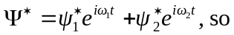
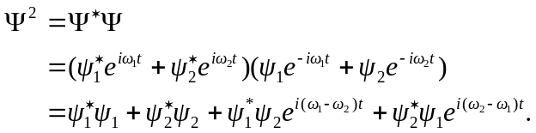
The frequencies 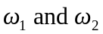 are given as not being the same, so 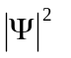is not time-independent, and 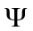is not the wave function for a stationary state.

